Budget App
Week 3 | 02/20/2026 - 02/27/2026

Leader: Jonathan Gruber

Jonathan Gruber  Time Spent  10 hours | Tasks completed:  - Refined architecture diagram  - Add .gitignore to Git repository  Planned tasks for next week:  - Update architecture diagram if needs be  - Work on back end  Any issues or challenges:  - TBD for architecture diagram:  - Database management system for backend  - LLM for financial/budgetary “insights”  - API contract for registration, login, profile, goals, and insights/forecast pages
Marcelo Mejia  Time Spent  5 hours | Tasks completed:  - Added a team/project homepage in Figma so that all members of the team can create pages in Figma and have them in a dedicated location for viewing, editing, etc.  - Created a calendar feature page in Figma. This page will allow users to see daily representations of their transactions, with emphasis on the income, expenses, and net balance of spending that occurs each day. Similar color scheme to original dashboard.  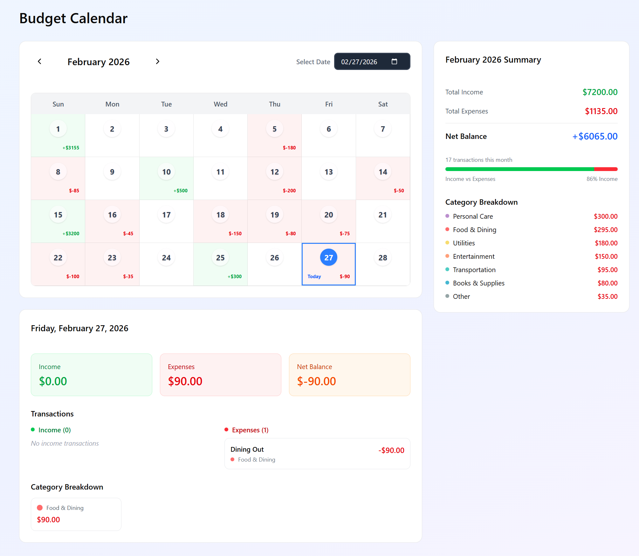  Functionalities of the calendar page:  - A user can cycle through months using the arrows at the top of the calendar  - A specific date can be chosen at the top  - Can show a daily report of spending that day, including any income/expenses and their categories, as well as a net balance for the day  - Can show a monthly report that is similar to the daily report, but showing the totals over the entire month + a income vs expense ratio  https://www.figma.com/make/qnrh3exNXE5zV9pUajddh3/Budgeting-Calendar-Page?t=YDygB09dXu8ur1Jk-1  - Implemented/converted the figma diagram to typescript on next.js while using CSS and other stylistic files to maintain the same look and feel of the original  - Pushed calendar feature files to Github and updated stories in Jira  Planned tasks for next week:  - Continue a cycle of frontend feature implementation with Figma and next.js until pages can be combined and more backend logic can be worked out.  Any issues or challenges:  N/A  Lingering questions:  - I'm having trouble visualizing our next steps after the diagrams of our feature pages are fleshed out on the front end. One of my teammates may be able to answer this, but what should we be working towards in terms of backend-to-front-end communication and implementation?
Sophia Chau  Time Spent  3 hours | Tasks completed:  - Creating specs  - Adding GitHub folders  - Adding Jira stories and managing sprint  Planned tasks for next week:  - Update specs with info from team  Any issues or challenges:  - I am still a little confused on some things that we need to add to the specs from the document the TA sent us  - Data models – how to make a good one  - API reference – is this the info that Cas created?  - Agent instructions and constraints – should we copy and paste these or create our own?  - Things we still need to update based on team feedback  - User flows  - UI/UX constraints  - Lingering questions  - The AI keeps wanting us to use Zod for validation. Should we add this or is it unnecessary?
Jonathan Strong  Time Spent  4 hours | Tasks completed:  - Added sign in page and a drop down menu with links to an expense page and AI budget page  - Reformatted the figma to work with next.js  Planned tasks for next week:  - Continue to build out front-end and ensure everything can link correctly with backend  Any issues or challenges:  - Had some issues trying to reformat it but then used cursor which helped  - Had some issues with committing but was able to figure it out
Casandra Marquez  Time Spent  7 hours | Tasks Completed  - Converted project to spec stack (Next.js, React 19, TS, Prisma, Postgres)  - Set up Postgres locally, ran Prisma migrations, confirmed DB works  - Fixed install and startup blockers (deps, DATABASE_URL user, ports)  - Created README for teammate setup and pushed branch to GitHub  Planned Tasks for Next Week  - Finish auth end to end (storage, middleware, full flow tests)  - Implement Expense CRUD from UI to DB  - Start Budget API and connect budget pages  Issues or Challenges  - Next and React version mismatch during install  - Postgres PATH and DATABASE_URL permissions issues  - Port 5000 conflict, moved backend to 5001
Haru Kimura  Time Spent  4 hours | Tasks Completed  - Designed a unified multi-page UI prototype for the student budgeting app in Figma, including sidebar navigation and consistent layout across screens  - Created a Transactions & Expenses interface that allows users to view, search, filter, and manage individual spending records  - Designed interaction flows for adding and editing transactions using modal dialogs  - Organized features into modular sections to support future frontend routing and backend integration  - Ensured visual consistency with existing dashboard design and overall application style  Planned Tasks for Next Week  - Refine UI based on team feedback and align designs with finalized specifications  - Assist with frontend implementation of transaction management features in Next.js  - Prepare designs for integration with backend APIs once endpoints are available  Issues or challenges  - Needed clarification on how UI structure should align with existing frontend architecture and backend endpoints.  - Coordinating design decisions with ongoing development work to avoid duplication of functionality.  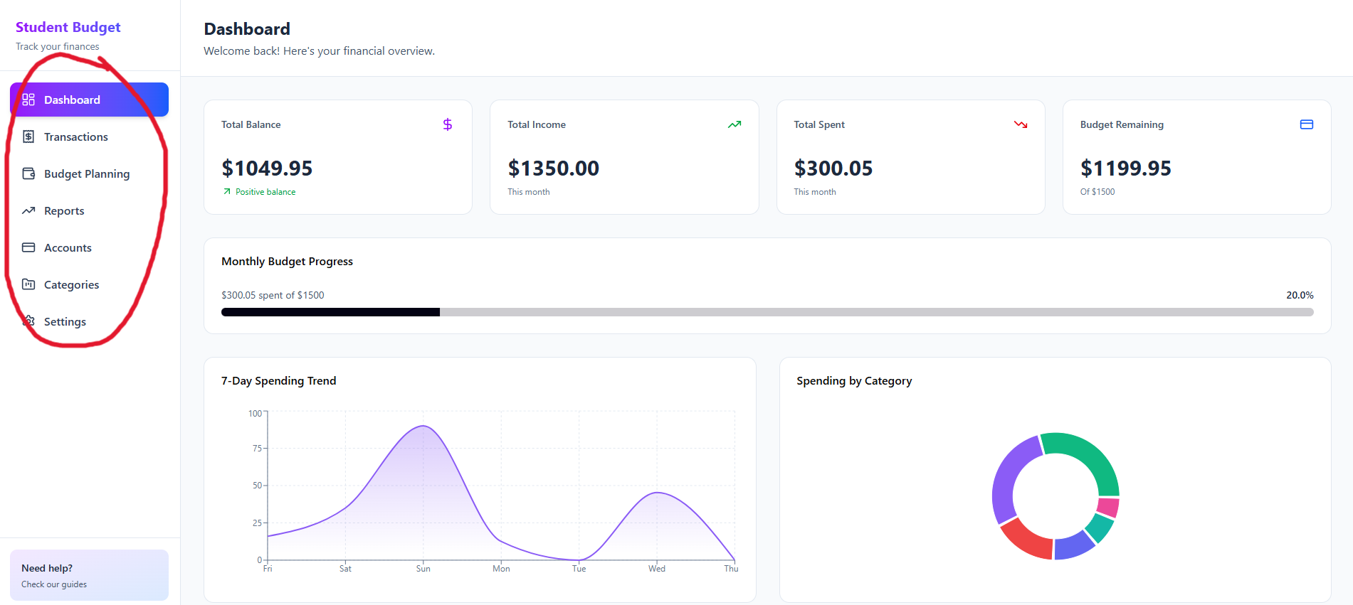

Total Time Spent: 33 Hours

Summary:

